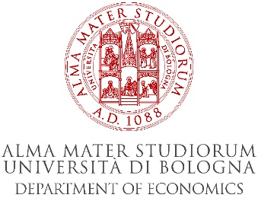

Protection of intellectual property rights and competition: India and Italy
Tuesday 23 July 2019
Sala seminari, P.zza Scaravilli 2, Bologna

A workshop jointly organized by the Department of Economics of the University of Bologna and O.P. Jindal University (India).

9.00- 9.45 Yugank Goyal (Jindal): “Compulsory Licensing”
9.45-10.30 Vincenzo Denicolò (Bologna): “Patent protection with sequential and complementary innovation”
10.30-11.15 Arun Kaushik (Jindal): “Probabilistic Patents, Alternative Damage Rules and Optimal Tariffs”

11.15 -11.30 Coffee break

11.30-12.15 Kathleen Modrowski (Jindal): “Protecting Cultural Heritage via IP rights”
12.15 -13.00 Andrea Mantovani (Bologna): “Much ado about nothing? Online platform price parity clauses and the EU Booking.com case"

13-14 Lunch

14.00-14.45 Mimi Roy (Jindal): “Intellectual Property Rights and Climate Change: The New Research Paradigm”
14.45-16.00 Luca Lambertini (Bologna): “Porter Hypothesis vs Pollution Haven Hypothesis: Can there Be Environmental Policies Getting Two Eggs in One Basket?”

16-16.15 Coffee break

16.15-17.00 Elena Argentesi (Bologna): "Estimating demand with multi-homing in two-sided markets"

